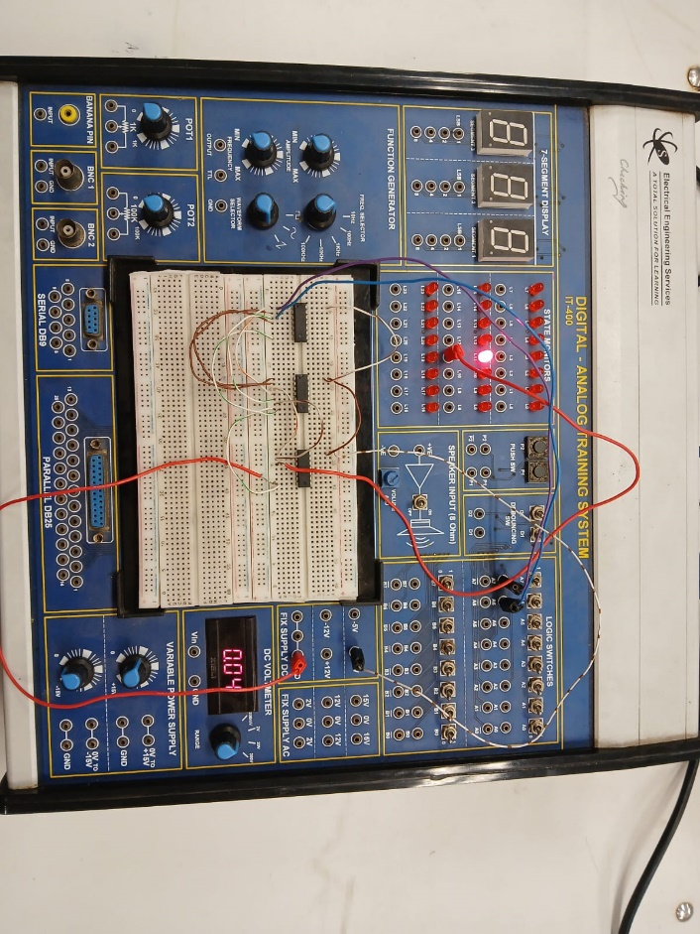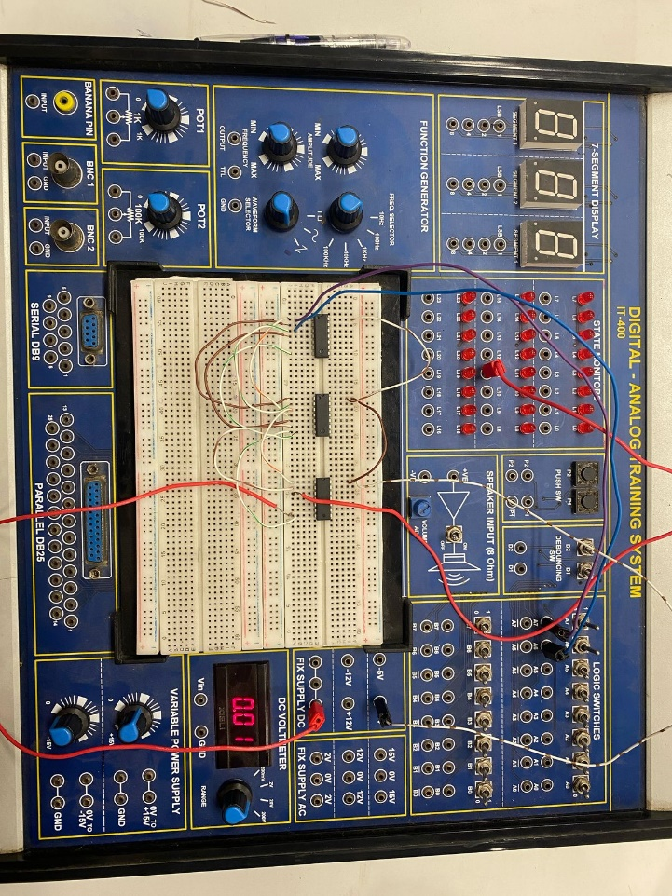**LAB 4 PHOTOGRAPHS**

XOR Gate using AOI Gate

XNOR Gate using NAND Gate